Parents and Guardians,

Starting in January, San Antonio will celebrate its 300th anniversary as a city. This Tri-Centennial is a very important landmark and San Antonio has made plans to celebrate all year long. As a part of the celebrations, San Antonio has made an enhanced effort to highlight Arts and Culture through various events and the sponsorship of major art installations around the city.

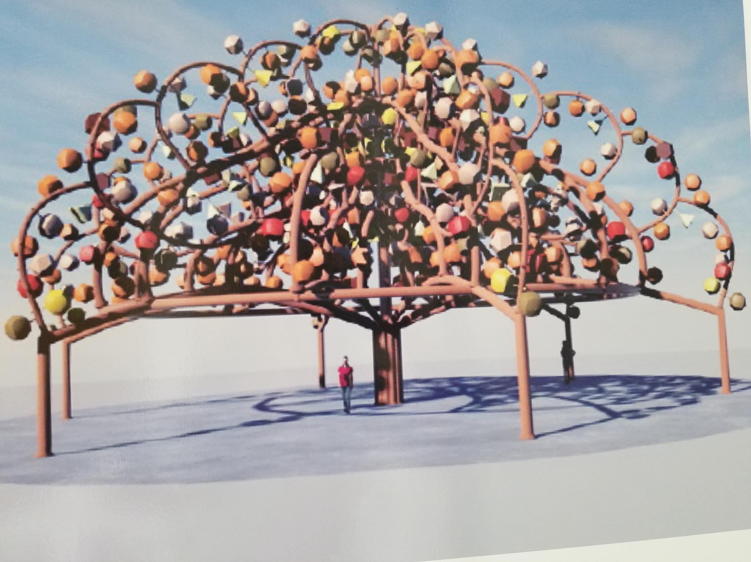
The San Antonio River Foundation has commissioned artist, Margarita Cabrera with the task of creating a large tree of life: Arbol de la Vida: Voces de la Tierra. This sculpture is a 40’ tall by 80’ wide collaborative sculpture project that tells the stories of the people of San Antonio and their rich family history. Students in Mr. Fallis’ AHJS Art classes have been tasked with the creation of 135 of the 700 ceramic sculptures that will adorn this amazingly important community art project. Artists and community members all around the city are being encouraged to break down barriers and work together around a common unified belief that your story is my story, because together, our stories are what make San Antonio such an amazing city.

Arbol de la Vida will be located at Mission San Francisco de la Espada, which is a part of the San Antonio Missions National Historic Park, recently named by the United Nations as a World Heritage Site. When completed, your child’s artwork, along with your family history will become a part of San Antonio’s collective and shared history available for the World to access and enjoy. San Antonio began as a town composed of a diverse group of people working together around a common goal to grow and develop for the prosperity of all. Today, we pay tribute to those roots and celebrate our diversity as we continue to grow and develop into the best city in the United States.

It is a very unique opportunity for our school to be asked to participate in what is potentially the most important sculpture this city will ever display. I am proud to guide AHJS students through the creative process and encourage you to help your children tell a story that you will be proud of as well. I have included a flyer with some details about this project and a release form that all students must return, signed by you. There will be additional information and plans that will come up during this process, so I will keep you informed.

Kindest Regards,
Casey Fallis
Art Education
Alamo Heights Junior School

